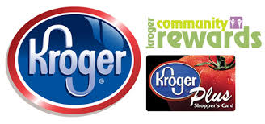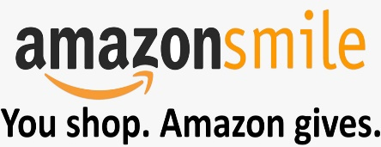
This Photo by Unknown Author is licensed under CC BY-NC-SA

Support McVay year round with: Community Rewards!
Kroger Plus Community Rewards: Shop, Swipe Card, Earn for McVay
Visit the Kroger web page: www.krogercommunityrewards.com
Sign in with current Kroger Plus Card or create a new card
Click My Account
Click Community Rewards (bottom of page)
Search McVay Elementary or GU480
Cards need updated annually to continue support for McVay!

Amazon Smile: Shop Amazon (Prime too) and earn for McVay

Visit Amazon web page: www.smile.amazon.com
Search McVay as your charitable organization
(PTA Ohio Congress McVay Elementary)
Use smile.amazon.com webpage when shopping Amazon to earn for McVay!

Giant Eagle Rewards Cards: Shop, swipe card, earn for McVay

Visit the Giant Eagle web page: www.GiantEagle.com/AFTS
Sign In with current Giant Eagle Account or create new account
Select Code: 3407 to earn apple points (transferred into cash) for McVay
Cards do not need updated to continue support for McVay annually

BoxTops Rewards: Clip BoxTops, or go digital and Scan Receipts in App!

Visit: www.boxtops4education.com to clip, scan digitally, and get coupons!

